IS2545 – DELIVERABLE 2: Unit Testing

GitHub: https://github.com/TianWahw013/IS2545-Software-Quality-Assurance-Deliverable-2.git

Tian Wang

tiw38@pitt.edu

**Description of Issues**

1. As the problem showed in the Fig.a-1, the type of visitor, the location and whether the visitor did like the location or not are all the same by using the seed.

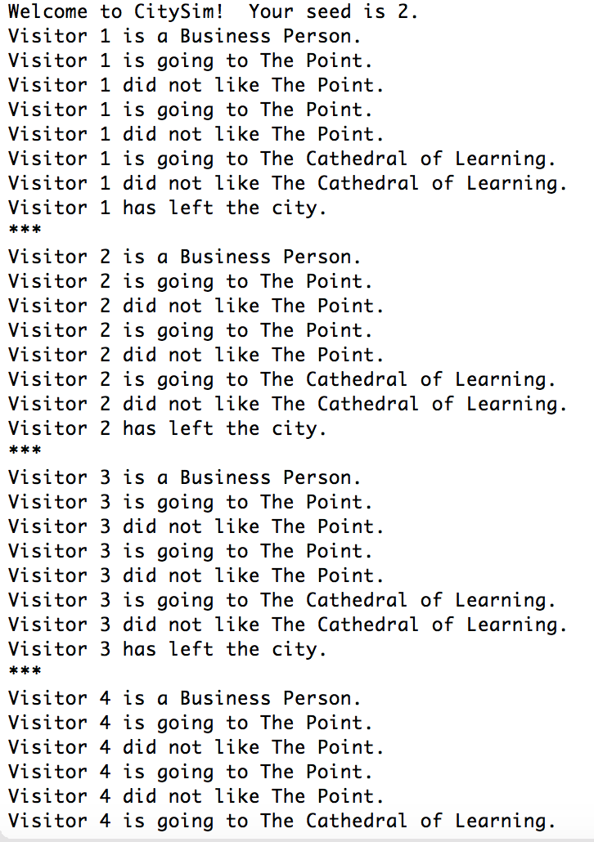

Fig.a-1

The reason that caused this problem is that I put the Random Number Generator in the five person for loop, which makes the for loop generate the same random number for five times.

To solve this problem, I just need to put the Random Number Generator outside the for loop.

1. For some reasons, it is hard for me to test by using the Mokito, I have adjusted the program code for fitting the test case. So I want to know how to write the code more efficiently for testing.

**Screen Shot of the Executed Unit Tests**

